Accentra Primo Umbrella

July 2019 (R1) Release Notes v1.0.6315
Release date 31st July 2019

Disclaimer
While all reasonable efforts have been taken to assure the accuracy and correctness of this manual and software, Accentra does not assume any liability whatsoever directly or indirectly for any errors or omissions and for its suitability for any specific purpose. The content of this document and software may change without notice and without any commitment on the part of Accentra.

.



Accentra Technologies Limited
Warnford Court
29 Throgmorton Street
London, EC2N 2AT
Confidential
The contents of this document are strictly confidential. No part of the contents of this document may be reproduced or transmitted in any form or by any means without the written permission of Accentra Technologies Limited.

s of this document may be reproduced or transmitted in any form or by any means without the written permission of Accentra Technologies Limited.
Table of Contents

1 Enhancements 3
1.1 Pension Contribution Submission 3
1.2 Bulk Timesheet Import 3
1.3 Invoice Method – Consolidate Items 3
1.4 Handling Email Failures for Mandatory Operations 3
1.5 Login Page Banner 4
1.6 View Pay Advice from Contractor Record 4
1.7 Contractor & Agency Portal – Show/Hide Sections 4
1.8 Pension Options 5
Support 6

Enhancements

Pension Contribution Submission
Settings -> Utilities -> Auto-Enrolment
Users now have the facility to submit pension contributions for the previous tax year by using the tax year dropdown box.
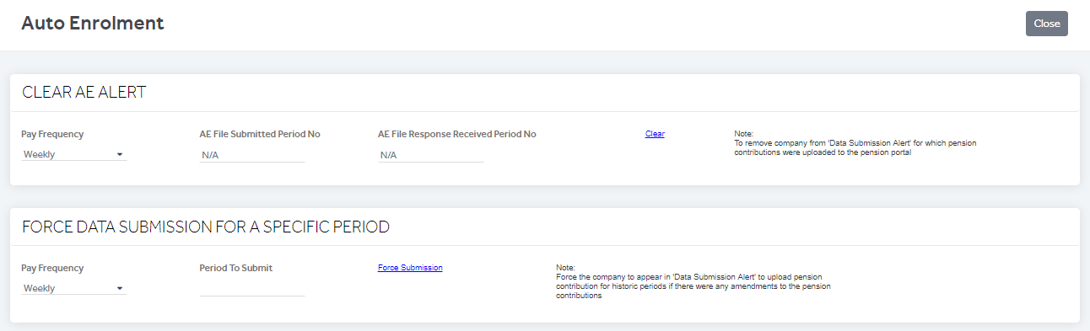

Bulk Timesheet Import
The bulk timesheet import function has been enhanced and can now process an import of over 6,000 timesheet records at a much faster speed.

Invoice Method – Consolidate Items
Auto Hide Menu -> Sales Invoices
Sales invoices are now consolidated based on the invoice method from the Agency Record. The change is also visible in the PDF format of the invoices under the 'Invoice Ref'. Click on the ‘Invoice Ref’ hyperlink to open the invoice. Invoices can also be customized as per requirements.
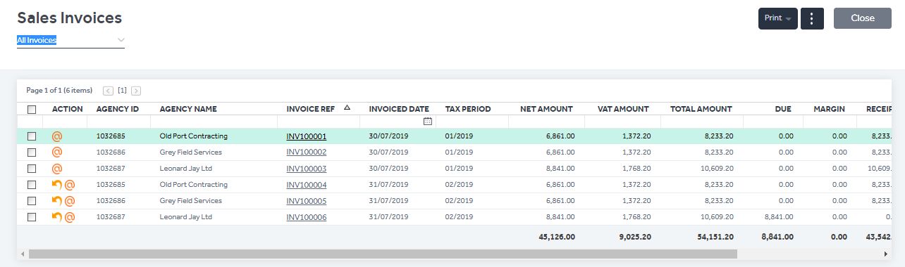

Handling Email Failures for Mandatory Operations
Even if company email settings are not available, the system will still send emails for the following important operations:
- Company Welcome Email on Signup.
- New user created within the company.
- New contractor created within the company and “Allow Portal Access” is set to “YES”
- Clicking 'Send Login' button from User List screen.
- Clicking 'Forgot Password' from Login screen.

Login Page Banner
Information on the latest third-party providers we have integrated with can now be viewed in the banner on the Primo Umbrella login screen.

View Pay Advice from Contractor Record
A new tab has been added to CIS contractor records to allow the user to view all available pay advice relating to that contractor. This is only applicable for CIS contractors and not PAYE contractors.
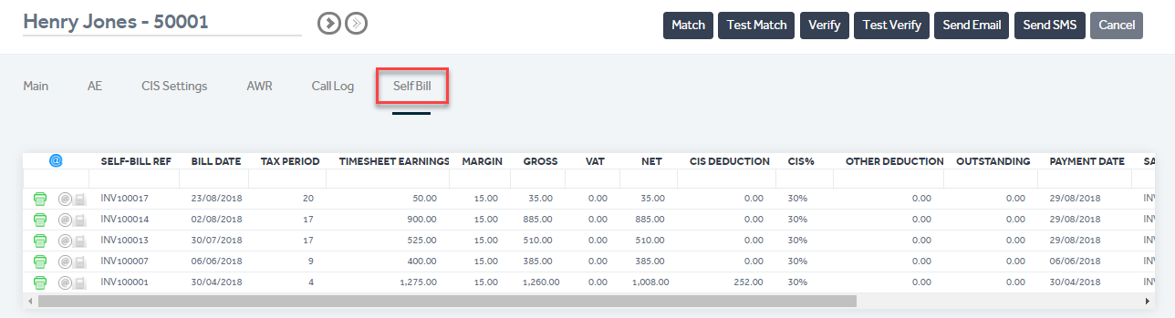

Contractor & Agency Portal – Show/Hide Sections
Company users can now alter access privileges to show or hide desired sections within both the contractor and agency portals.
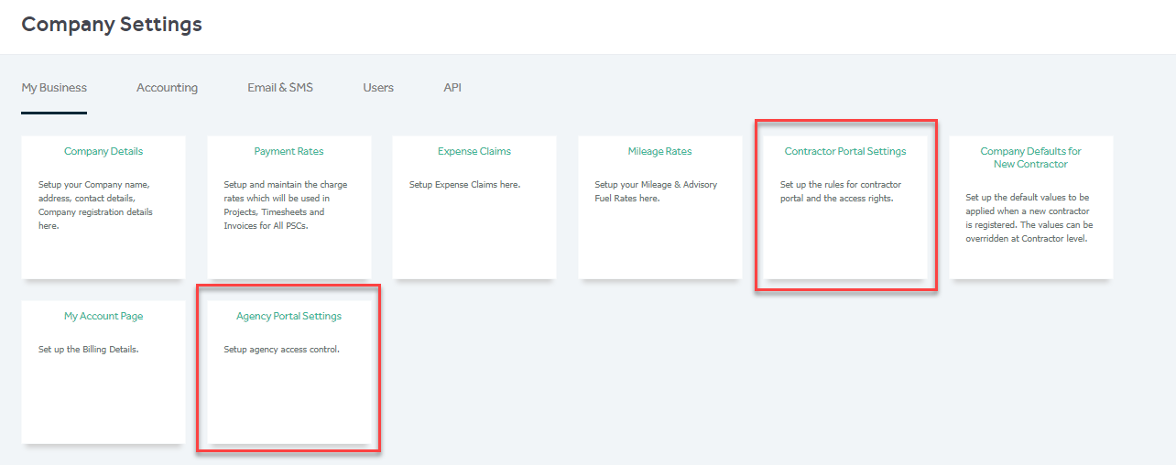

Pension Options
Employers now have the ability to Opt in, Opt out or cease an employee’s pension contributions from the employee list screen.
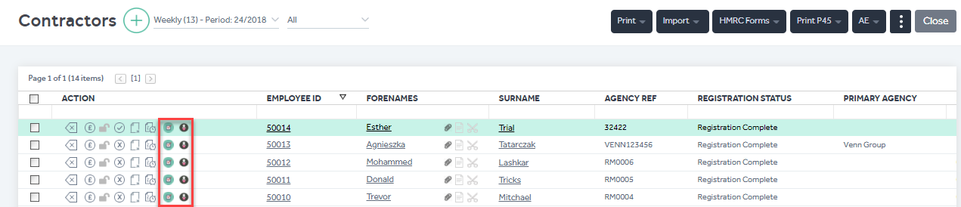

Note: As there have been few design changes on the portal, please press (Ctrl + Shift + R) to update your cache to the latest version when you login to the portal if you’re experiencing continuous loading/freezing issues.

Support
We welcome any suggestions for improvement of the software. Please email to the below mentioned email.
Please email the support team: support@accentra.co.uk before you call. This will generate a ticket and allow our team to respond promptly. Always include your Payroll company ID and contact details in the email.

You can call for any support to
PRIMO Payroll support team
Accentra Technologies Limited
Warnford Court
29 Throgmorton Street
London
EC2N 2AT, U.K.
Phone: 0845 456 7181
www.accentra.co.uk

